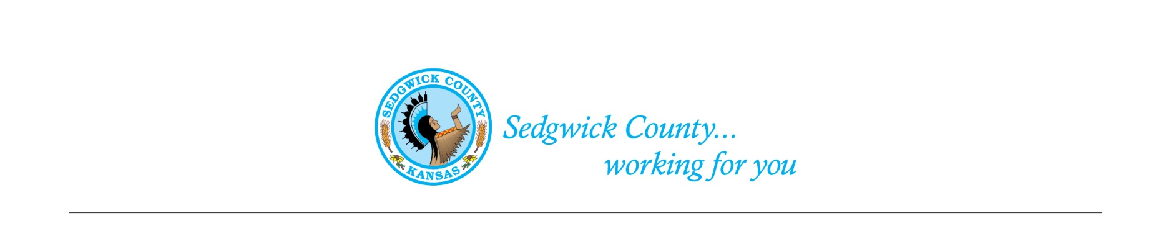
Sedgwick County Animal Care Advisory Board meeting
Animal Control
Sedgwick County Health Department
1015 Stillwell, Wichita, KS 67213 - www.sedgwickcounty.org - TEL: 316-660-7078 - FAX: 316-383-7553
Nika Orebaugh, Animal Control Supervisor
Program Supervisor
Of August 13, 2020
Attendance:
Advisory Board
Members- Susan Erlenwein, Simone Ward, Laura Adkins, Shanti Leiker, Linda Wiley, Geri Watts, Dr. Julie Evans, and Debbie Miller. Members attended in person, by phone and WebEx.
Absent- Shelley Seidl
Public- No public in attendance
Sedgwick County Staff- Nika Orebaugh, Mitch Waegener

1. Minutes: Discussion and approval of June and July 2020 minutes. Moved and second by Laura Adkins and Simone Ward. Approved by majority vote.

2. Old Business:
A. Discussion on Breeding Dogs Draft Regulations (continued) – Susan Erlenwein reviewed the agreed-upon changes to the Dog Breeding regulations made at the previous meeting. Board members agreed to the changes and discussed fees for the dog breeding facility, the maximum number of dogs allowed and inspections (staff can use state shelter forms). Susan will add the agreed upon information to the draft regulations.
4. New Business:
A. Staff Update- Nika Orebaugh advised members of the following activities:
- Due to the COVID-19 restrictions, there will not be a Parvovirus Vaccination Clinic and Rabies Clinic this year.
- Animal Control staff continue to assist the Health Department in their COVID-19 efforts.
- Nika would like to Change the current Sedgwick County Animal Control regulations in several areas: change our code to include the new proposed State Regulations on non-human primates (can be accomplished by adding nonhuman primates to the definition of inherently dangerous animals); add language to our rabies section to state that it conforms with the current state Rabies Control Requirements; and add “failure to provide veterinarian care” under the Inhumane Treatment section in our Code. Nika will develop these recommendations to give to the Legal Department at a future meeting. Simone said that all three recommendations can be placed in a resolution for one agenda item at a future Commission meeting.
- Discussion was held on the City of Wichita’s proposed changes to the Animal Shelter and how that might affect the Sedgwick County Animal Control budget.
- Kansas is the last state in the nation that prohibits the adoption or release of cats with FeLV, except to its owner. Midge Grinstead, the Kansas State Director for the Humane Society of the United States, is working to have this changed in order to allow adoptions and release of FeLV positive cats. Board members can contact Midge to help in this endeavor.
5. Public –Public was not present at this meeting.

6. Adjournment – The Board agreed to adjourn and have our next meeting on September 10th.

