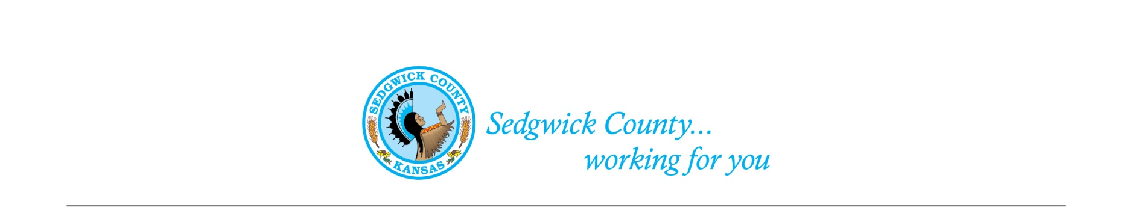
Sedgwick County Animal Care Advisory Board Meeting
Animal Control
Sedgwick County Health Department
1015 Stillwell, Wichita, KS 67213 - www.sedgwickcounty.org - TEL: 316-660-7078 - FAX: 316-383-7553
Nika Orebaugh, Animal Control Supervisor
Program Supervisor
Of June 8, 2023
Attendance:
Advisory Board
Members - Susan Erlenwein, Simone Ward, Janna Hays, Debbie Miller, Shanti Mikolajczyk, Shelley Duncan and Dr. Julie Evans
Absent - Patricia Miller
Public - Linda Leatherman and Heath Hazen
Sedgwick County Staff - Dina Ingram and Dakota Kidd
1. New Business: Due to guests who wanted to address the Board, Susan moved New Business to the start of the meeting to allow the guests to leave prior to Old Business if they wished to do so.
A. Adrienn Clark reviewed our update to the Habitual Nuisance Animal Violator proposed Code, and added comments where she had questions and concerns. This was emailed to the Board members prior to the meeting. We reviewed the comments and required more detailed information to address the concerns. Susan will meet with Nika and Adrienn prior to our next meeting to review comments and try to finalize a draft for review by the Board.

B. Other New Business: There was no other new business to come before the Board.

2. Old Business:
A. Minutes: Discussion and approval of May 11, 2023 minutes. Moved and seconded by Simone Ward and Julie Evans. Approved by majority vote.
B. Proposed Sedgwick County Animal Shelter: Shanti had reviewed the current draft of the Animal Shelter Proposal and had added recommendations. She emailed them to Susan, who provided copies to the Board. We reviewed the changes and added more information to the document. A discussion was also held on potential funding options for a new shelter.
3. Staff Update- Dakota provided an update on recent activities.
4. Public –Linda thanked the Board for continuing to look into changing current regulations pertaining to owners of habitual animal violations.
5. Adjournment – The Board agreed to adjourn at 7:40 PM.

