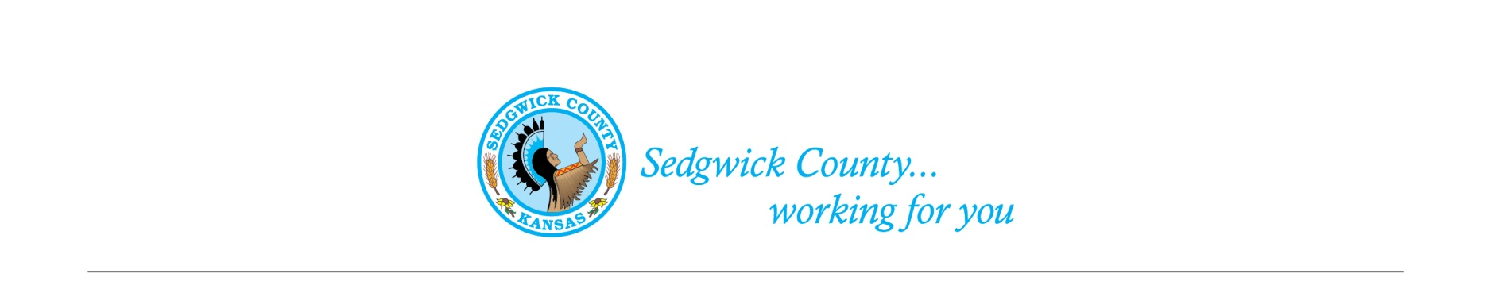
Sedgwick County Animal Care Advisory Board Meeting
Animal Control
Sedgwick County Health Department
1015 Stillwell, Wichita, KS 67213 - www.sedgwickcounty.org - TEL: 316-660-7078 - FAX: 316-383-7553
Nika Orebaugh, Animal Control Supervisor
Program Supervisor
Of February 15, 2024
Attendance:
Advisory Board: Members - Susan Erlenwein, Simone Ward, Janna Hays, Dr. Julie Evans, and Susan Lentz
Absent – Shanti Mikolajczyk and Shelley Duncan
Public – Jodi Tronsgard
Sedgwick County Staff –Nika Orebaugh
1. New Business:
A. Minutes: Discussion and approval of January 11, 2024 minutes. Approval of the minutes was moved by Simone Ward and seconded by Susan Lentz. Motion was approved by majority vote.
B. Board Members: Susan Erlenwein mentioned that two new members were recently appointed to the Board.
C. Election of Chair and Vice-Chair: Julie Evans moved and Susan Lentz seconded to elect Susan Erlenwein as Chair and Simone Ward as Vice-Chair. Motion was approved by majority vote.

2. Old Business:
A. Review proposed Code changes recommended by the Legal Department on Habitual Nuisance Animal Violators: Susan Erlenwein reported that the Legal Department has our approval on their recommendations regarding that habitual nuisance animal violator cases go in front of a District Judge instead of a County Judge. She will let the Board know when Legal returns the document.
B. Proposed Sedgwick County Animal Shelter: Susan Erlenwein noted that she and Nika had met to discuss the type of statistical information we need to gather for the Shelter and Animal Outreach Program Portfolio. Nika brought handouts to the Board and reviewed the data on animal intake and status at the Wichita Animal Shelter over time. Discussion was held on the need to rebuild bridges between nonprofit animal organizations and the Wichita Animal Shelter. Nika reviewed her interactions with these organizations. Janna Hays encouraged all of us to meet an April deadline of obtaining the missing information for the proposed Animal Shelter. All were in agreement.
3. Staff Update- Nika reviewed some recent cases they have encountered.
4. Public – Jodi mentioned that it was good to see a Board working together as a team. She does want to be included in future meeting notices.
5. Adjournment – The Board agreed to adjourn at 7:55PM.

