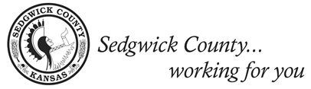

District 2 Citizens Advisory Board Meeting
Agenda

Tuesday, April 12, 2022 Haysville Community Library

6:00 p.m.

Board members: Dr. William D. Hammers, Spencer Dean, Jr., Manuel P. Lopez, Jenny Duong, Dr. Susan Parkinson Norton, Martha Ann Pint, Jan Marple, Nicole Helms, Anthony Lee Gonzales, Tabitha Lehman, Ashlie Brockleman
County/City representatives: Malichi Winters

ORDER OF BUSINESS

- Call to Order - Nikki Helms
- Roll Call Vote
- Approval of minutes

Public Agenda
The public agenda allows members of the public to address the Second District Citizens Advisory Board.

NEW BUSINESS

- ICT-1
  - Presented by Malachi Winters
- Discussion of Future Agenda Items

ADJOURNMENT

The next Citizens Advisory Board Meeting will be Tuesday, May 10, 2022

