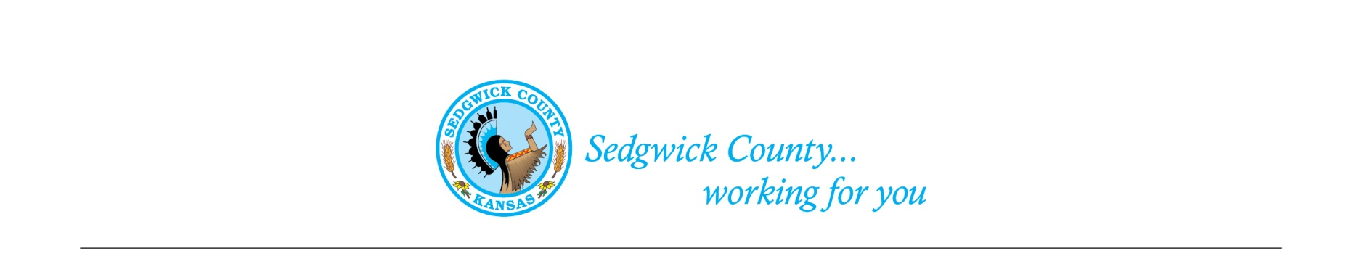
Sedgwick County Animal Care Advisory Board Meeting
Animal Control
Sedgwick County Health Department
1015 Stillwell, Wichita, KS 67213 - www.sedgwickcounty.org - TEL: 316-660-7078 - FAX: 316-383-7553
Nika Orebaugh, Animal Control Supervisor
Program Supervisor
Of May 9, 2024
Attendance:
Advisory Board: Members Present - Susan Erlenwein, Simone Ward, Janna Hays, Dr. Julie Evans, Shelley Duncan, Susan Lentz, Shanti Mikolajczyk, and Erika Lovett
Members Absent –Kylee Wallentine
Public – None
Sedgwick County Staff –Nika Orebaugh, Dakota and Dina Ingram
1. New Business:
A. Minutes: Discussion and approval of April 11, 2024 minutes. Approval of the minutes was moved by Shelley Duncan and seconded by Janna Hays. Motion was approved by majority vote.
B. KORA RULES: Susan Erlenwein reviewed the KORA open meeting rules, and reminded members to never “reply all” to an email.
C. Report on KDA developments and how they will affect Sedgwick County operations: Nika Orebaugh brought the Board up-to-date on recent developments in the Kansas Department of Agriculture (KDA). They have opened a Public Forum on their web site for comments.

2. Old Business:
A. Review of ACAB proposed Code Changes: For the benefit of new members, Susan Erlenwein distributed and reviewed the Exotic Animal proposed Code and the Dog Breeding Proposed Code. The Board did not recommend any changes. Susan will discuss with Legal about steps needed to get these approved by the County Commissioners. We also discussed the proposed Reckless Pet Owner proposed Code. The Legal Department is investigating how to address the issues. Especially the taking of a pet. Research on other Kansas regulations shows that this option has been struck down in court.
3. Staff Update- Nika reviewed a hoarding case with mixed Chihuahuas and reviewed some upcoming events, including two Fairs. She mentioned there are some scams going on concerning false information about Animal Control picking up an injured dog and wanting lots of money for its return.
4. Public – None
5. Adjournment – The Board agreed to adjourn at 7:12 PM.

