March 1, 2024
Sedgwick County Emergency Management
2023 Annual Report

Our Vision
A resilient and sustainable community
Our Mission
Build, sustain, and improve Sedgwick County's capabilities in disaster prevention, preparedness, mitigation, response, and recovery through whole community collaboration, innovative planning, training, and exercise activities

Emergency Management Staff
Inside this Issue
Staff/Table of Contents 2
Meet the Staff 3
Accomplishments and Highlights 4-5
EM Volunteers 6-7
Community Outreach/Education 8-9
Planning 10
Preparedness 10
Exercises 10-11
Logistics 11-12
Operations 13
Collaboration 14
In the Media 15

Julie Stimson Jonathan Marr
Director Deputy Director

Cody Charvat Jonathan Schropfer
Operations Planning

Kenji Brooks
Logistics

Emergency Management Volunteer Teams
Roger Teachman Wayne Leach
Radio Officer, RACES K9 Team Lead

Ed Giesen Darryl Staats
CERT Team Lead CERT Team Lead

Andy Ralstin Vincent Karpinski
CERT Team Lead CERT Team Lead

Sara Magnasco Kyla Hargraves
CERT Team Lead CERT Team Lead

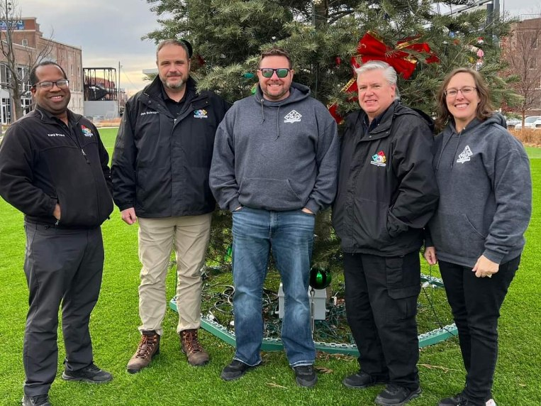

Our Award-Winning Staff

Julie Stimson, CEM, Director

Julie was one of 3 Kansans selected to the class of 2023 U.S. Global Leadership Coalition, Next Generation Global Leaders Network. The USGLC Next Gen program is bipartisan program designed to train, network, and empower a diverse group of leaders from the U.S. to become advocates for America’s development and diplomacy programs. Julie attended nine 90-minute virtual sessions learning about key foreign policy issues and attended the USGLC Global Impact Forum in Washington D.C. in June where she and her cohort were able to meet with and share unique local insights with policymakers. Some topics discussed included climate change, foreign aid, competition with China, and the War on Ukraine. Julie graduated the program in December, 2023 and now is a member of the USGLC State Advisory Committee. Julie also passed her PhD comprehensive exam this summer and entered into the final dissertation phase.

Jonathan Marr, Deputy Director
Jonathan had another award-winning year with Emergency Management. This year he was awarded his KCEM designation as a Kansas Certified Emergency Manager and the St Hubert’s Award for locating a missing person involved in a state-wide silver alert. Jonathan made significant headway on our Outdoor Warning CIP as well as our public outreach and volunteer teams. Jonathan’s work grew our volunteers from 15 to over 70 through teaching the Community Emergency Response Team Basic training program. Jonathan also work diligently to refurbish all of our trailers and equipment. At the very end of December Jonathan accepted the first-ever fire marshal position in the City of Derby. Jonathan will be missed by many, but plans to remain active in the CERT program.

Cody Charvat, KCEM, Operations

2023 was Cody’s 25th year as a county employee and his 40th year in Public Safety. Cody continues to be the foundation of our department. Cody taught or coordinated over 30 classes and training sessions to educate our county partners. He managed the Emergency Operation Center, our in-house Emergency Management Training Programs, teaches Storm Spotter training to our partners, and manages our IPAWS and mass communication programs. The final days of 2023 saw Cody promoted to Deputy Director to replace the departing Jon Marr.

Jonathan Schropfer, Planning

This summer we welcomed our newest member of the team, Jonathan Schropfer. Major Schropfer recently retired from the U.S. Army as a Future Operations and Counter Weapons of Mass Destruction Planner. In the short time Jonathan has been with us, he has taken the reigns to start the five-year comprehensive review of the Region G Hazard Mitigation Plan. He is also assisting several organizations update and develop continuity plans. We welcome Jonathan and his family, wife Dawn, and sons Gus and Walter.

Kenji Brooks, Logistics

Kenji continues to coordinates our logistics supplies and spearhead our administrative operations. This year he dialed in what supplies and product are necessary to have on hand that will combat supply interruption. Kenji’s focus this year was to accurately document and analyze data to prepare the department to take on the PPE financial burden. 2024 will be the last year the County will have to use the American Rescue Plan Act (ARPA) federal grant money to purchase PPE supplies that we all have enjoyed using since 2020 and in preparation we will submit a decision package for 2025 to allow Emergency Management to rotate items that have a shelf-life expiration date.

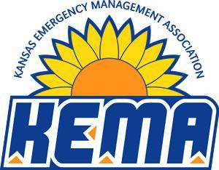
All staff members belong to the Kansas Emergency Management Association (KEMA). KEMA was formed in 1977 and is a network of leaders dedicated to providing excellence in emergency management and homeland security for Kansas. KEMA is committed to promoting excellence through professionalism, fostering communication and cooperation through teamwork, soliciting input and active participation through responsiveness, and advocating for progressive growth through leadership.

Accomplishments and Highlights

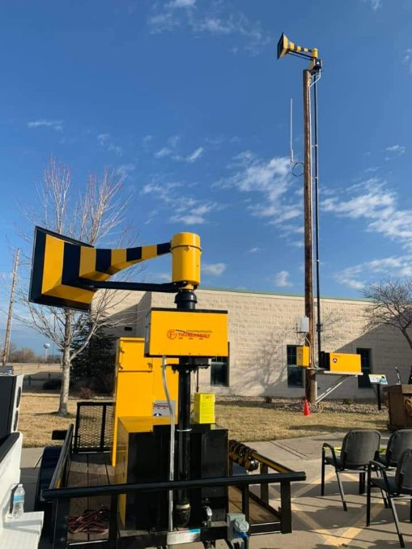
The World’s Oldest Thunderbolt Siren Still in Service
Sedgwick County Emergency Management held a ribbon cutting event on March 4 in honor of the four world’s oldest Thunderbolt sirens still in service here in Sedgwick County.
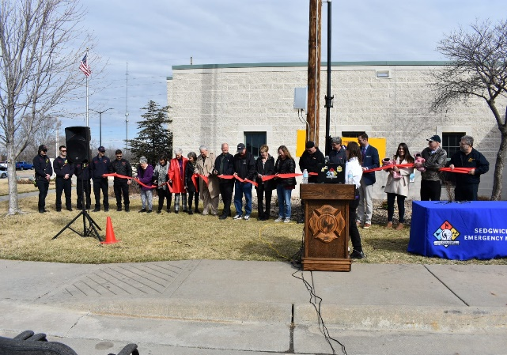
Kenneth Urban (K.U.) Benjamin and Sgt. Paul Hansen were honored at this event for their significant part in severe weather awareness in our county. K.U. Benjamin installed 13 sirens throughout Wichita, four of which are still in service today. His volunteer work changed the way we warn the public of danger, and it is a sound nearly every Wichitan has heard since 1952. On the night of June 10, 1958, Sgt. Paul Hansen made the decision to activate the Thunderbolt Air Raid sirens to warn of a weather event. It is the first time such a thing had happened, at least in Sedgwick County, and we have been doing it ever since. There is no way to quantify the number of lives that may have been saved in the decades that followed. Family members of both K.U. Benjamin and Sgt Paul Hansen came in from across the country to attend this historic event.

These 70 year old historic outdoor warning devices can be seen at Sedgwick County Fire Station (SCFD) 32, SCFD Station 38, Wichita Fire Station 20 and on a traveling exhibit used by Sedgwick County Emergency Management.

Jonathan receives the St. Hubert Award for locating a missing person

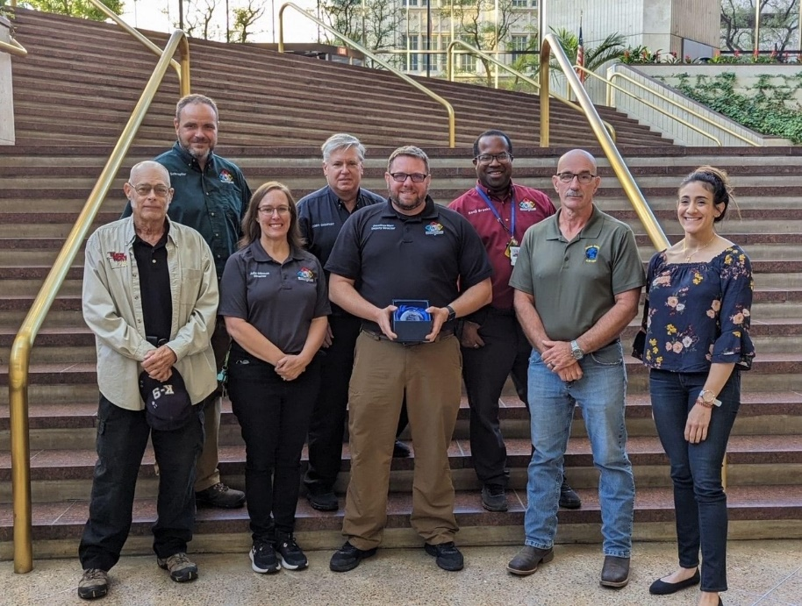
On September 9th, 2023 a state-wide Silver Alert was issued for an individual with dementia in the area of North High School. At about 4pm, the Sedgwick County K9 Search Team (SCK9) was requested by Wichita Police to assist with the search. Multiple K9’s, handlers, and flankers responded and searched until dark with no leads. Later that evening, the Wichita Police received a tip that the missing person was seen at a QuikTrip over 10 miles away in southeast Wichita. Wichita Police again requested the K9 Search Team at around 11:00pm, who responded with a several Handlers, K9’s and flankers. Jonathan discovered the missing person had recently moved to Wichita from Andover and assumed he may be headed home. At 11pm he drove his vehicle to the individual’s previous address and starting to search roads leading back to the QuikTrip. At about 1:15am, the missing person crossed the beam of Jonathan’s spotlight. He stopped and confirmed he had located the correct person, earned the individuals trust and returned him safely back to his family. This is not work typical of Emergency Managers and for his efforts, Global Safety K9 Safety Ops awarded Jonathan with the 2023 St. Hubert award. St. Hubert is the patron Saint of Hunters and Dogs and is typically awarded to K9 handlers who make a find. Jonathan, who is allergic to dogs, is not a K9 handler, however, he manages the K9 Search Team. We’re grateful for Global Safety K9 Ops recognition of Jonathan’s find.

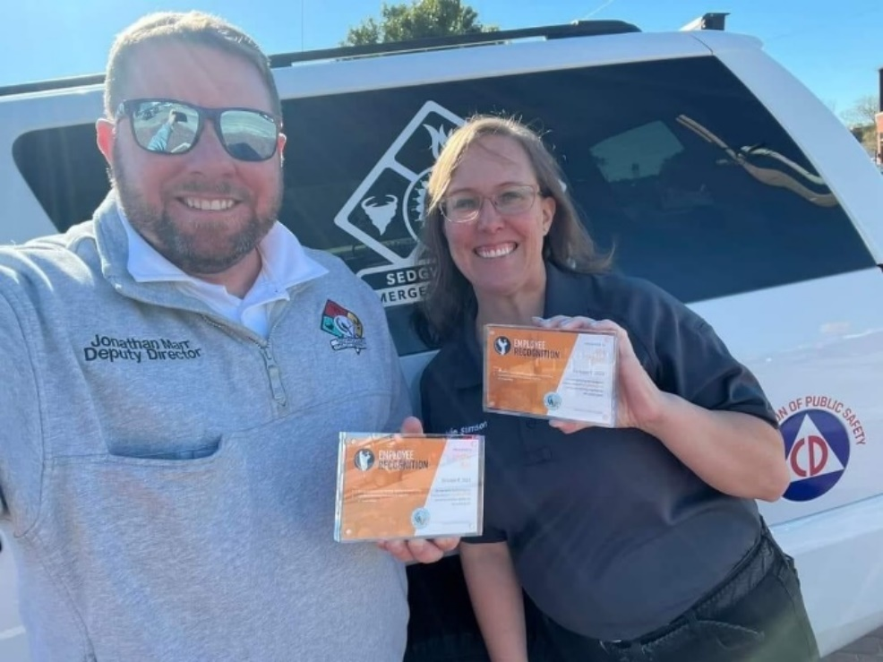

Julie and Jonathan received Sedgwick County Value

Awards for Collaboration!
Julie and Jonathan received value awards as part of Sedgwick County’s annual value awards ceremony. County Manager Tom Stolz led the award breakfast at Intrust Bank Arena. While employees nibbled on breakfast, Marché Fleming-Randle, PhD, of Wichita State University gave a keynote speech on the value of public service

Emergency Management Volunteers

We have focused our efforts to remove barriers to volunteerism by supporting the vital work they do and empowering them through education and other means. Based on figures from the Non-profit Leadership Center, Emergency Management’s volunteer programs have saved Sedgwick County about $200,000 in costs. Emergency Management doubled its volunteer work force in 2022 and then doubled those 2022 numbers in 2023.

LOCAL EMERGENCY PLANNING COMMITTEE (LEPC)

The mission of the Sedgwick County LEPC is to fulfill the requirements of the Superfund Amendments and Reauthorization Act of 1986, commonly known as SARA Title III. In addition, the LEPC is an all-hazards planning committee to include information sharing, community planning, exercise design/implementation, the critique of emergency incidents—real or exercised, other activities aimed at efficient, compassionate, and rapid response to disaster survivors’, caregivers’, and workers’ needs in times of disasters. As required by the Emergency Planning and Community-Right-to-Know Act (Public Law 99-499) and K.S.A. 65-5701 et seq., the LEPC ensures that Emergency Operations Plans, Material Safety Data Sheets (MSDSs) and Tier II forms are submitted annually by the regulated business entities within Sedgwick County and are available for inspection upon request at Sedgwick County Emergency Management. The committee is led by volunteer Chairperson Ann Houk who is the Administrator at Home Health & Hospice of Kansas, LLC. Ann volunteers hundreds of hours per year to lead the committee made of up nearly 50 active community members through all-hazard planning, training and exercise activities. Ann spent countless hours working with state and local response agencies to identify exercise and training needs for first responders. Funded through the Hazardous Materials Emergency Preparedness grant, Ann was able to secure 6 courses to enhance response capabilities in the county. Ann’s hours of dedication to community preparedness and public safety earned her the nomination as the Support Person of the Year at the Kansas Emergency Management Association annual conference.

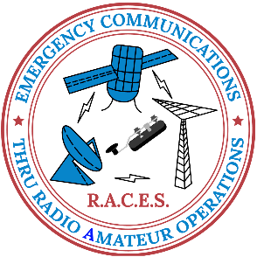
Sedgwick County Radio Amateur civil emergency service (R.A.C.E.S.)

R.A.C.E.S. volunteers logged over 1200 volunteer hours in 2023. Through the twenty-nine members of our R.A.C.E.S. Team, Sedgwick County Emergency Management maintains a backup radio communication system consisting of four repeaters and many radio operators. HAM Radio infrastructure nationwide has served as a reliable primary and secondary communication system in times of disaster and war. When activated, the R.A.C.E.S. team provides radio communications for us in times of emergency. These volunteers and the infrastructure they maintain are a critical backup when our primary communication goes down. R.A.C.E.S. meets every Tuesday evening for training and they perform radio checks every Sunday. Our R.A.C.E.S. Team also receives advanced storm spotter training; when storms approach, they deploy into the field to report on severe weather. Our R.A.C.E.S. Team is a critical part of our resilience.

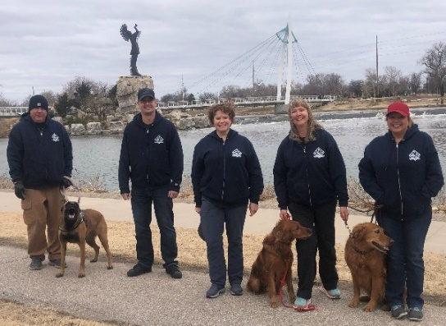
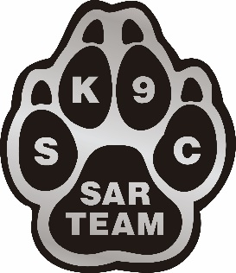
Sedgwick County Emergency Management K9 Search Team

Our K9 Search Team (SCK9) has logged over 2000 hours of volunteer service in both training and deployments this year. Our K9 Handlers serve as part of our disaster response team to help search for people who have gone missing in the wake of a disaster. Because disasters don’t happen every day, they often keep up on their skills by supporting our local law enforcement partners to search for lost or missing adults and children. This year, SCK9 was requested and deployed to assist the following agencies with their investigations: Wichita PD, Sedgwick County Sheriff, Wichita Fire, Butler County Sheriff, Sumner County Sheriff, Chase County Sheriff, McPherson PD, the Kansas Highway Patrol, and the Nebraska State Patrol. Our K9 team provides services including, air scent, trailing, water search, and human remains detection by request. We currently maintain the largest vetted and organized team of K9 handlers in the region. Although this is a disaster team, by extension, it allows us to further build relationships with our partner agencies. The development of these relationships is critical to our ability to respond to disasters under a unified command structure.

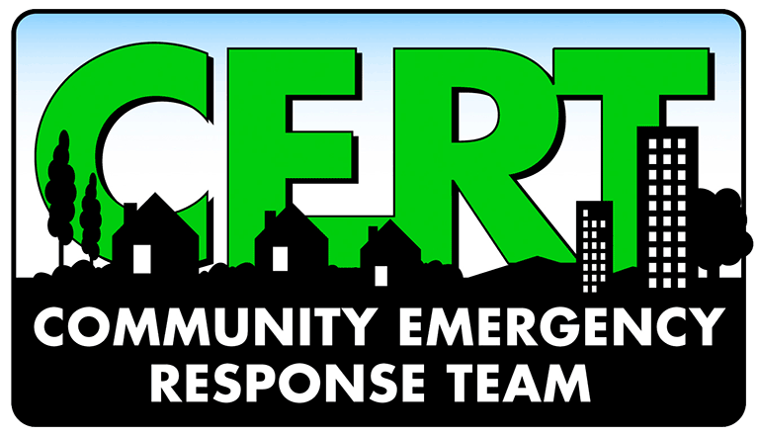
Advanced Community Emergency Response Team

It’s finally here! The Advanced Community Emergency Response Team launched in August of 2023 with an initial membership of 20 Basic Training Graduates. This regular team of volunteers will meet monthly and receive additional training to support emergency management and our community during a disaster. CERT programs across the country differ based on the needs of our community. The recent tornado on April 29th, 2022 and the subsequent after-action report gave us a logical place to start for revitalizing our own local program. It’s our goal to fill some of the response/recovery gaps highlighted in the after-action report with our CERT volunteers. To do this, we had to design a program around the work functions where we were short on help. We’ve identified the following functional areas for our CERT Program volunteers: damage assessment recon, light search & rescue, volunteer reception, generators & lighting, logistical support, emergency shelter support, public outreach, and more. The team is off to a great start and we’re hopeful for the future.

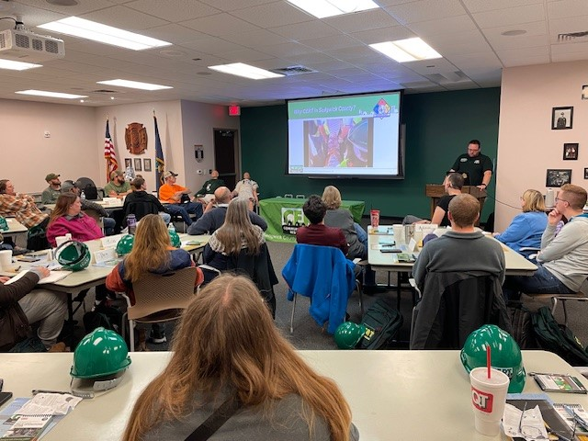 | 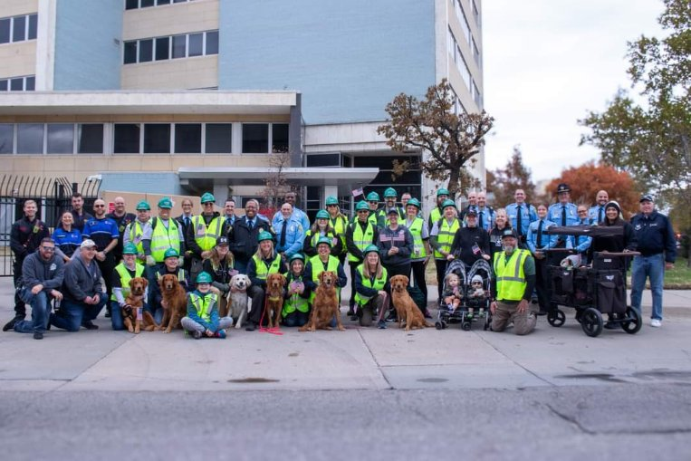

Community Outreach and Education

Storm Fury on the Plains

The annual severe weather safety class developed by the National Weather Service and presented across the County by Emergency Management returned to a full schedule of offerings for the first time since COVID. This class, while open to the public, is also critical training for volunteer firefighters and others who assist Emergency Management with storm spotting during severe weather. In 2023, Cody provided 19 offerings with a total attendance of 378. New in 2023, Cody developed a 1-hour severe weather safety class specifically for school bus drivers; five districts took advantage of this opportunity with 200 drivers in attendance.

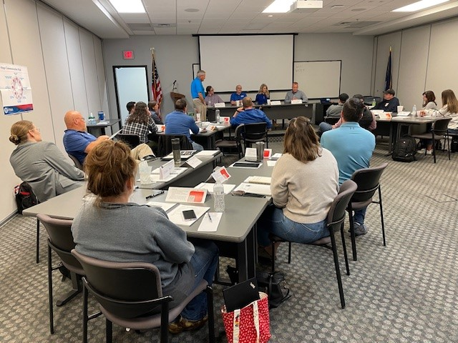
First Responder Education

In addition to weather, Cody facilitated the delivery of 9 other classes in a variety of topics. These classes provided 1400 hours of continuing education for our first responders and assists our first response agencies with meeting the objectives in our Local Emergency Operations Plan (LEOP). In 2023, Emergency Management hosted the following classes for our partner agencies.

- Electric Vehicle Battery Hazmat
- Crisis Management for School-based Incidents
- Basic Public Information Officer
- Staging Area Manager
- EOC Orientation
- Emergency Log training
- CivicReady for City Admins
- Emergency Building Coordinator for WSU

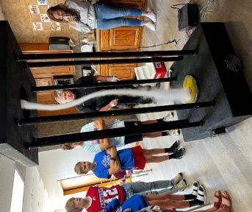
Emergency Preparedness Education in Schools

One of the more popular attractions at our community outreach events, especially with children, is our homemade tornado machine, which uses fans, dry ice and water to produce a "tornado" the kids can touch. In this photo Cody uses the machine to teach tornado safety to the students attending Cheney’s Government Day for 7th graders. This year we participated in the Derby STEMKAMP as well, educating youth on disaster preparedness and storm/tornado safety. Our outreach covered higher education as well, as once again we were asked to provide training to WSU’s Emergency Building Coordinators to help them understand their roles in campus emergencies.

And our school outreach was not limited to the traditional school year. In June our whole staff, along with over a dozen community partners, helped Derby Public schools wrap up their summer STEM Camp for over 400 students, teachers, and parents.
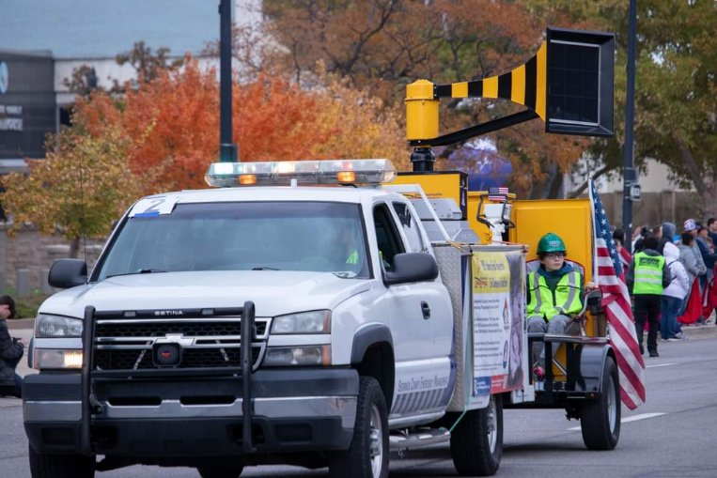

SCEM In the Community
2023 was an especially busy year for our staff and volunteers when it came to Community Outreach. We provided a half dozen presentations to businesses and civic groups on the basics of disaster preparedness; we took part in parades for Riverfest, Park City (4th of July), Haysville (Fall Fest), and Veterans Day. We were involved with Open Streets ICT, a STEM Camp in Derby, the Clearwater Fall Festival and National Night Out in Bel Aire. Our Thunderbolt siren trailer and K9 Team volunteers with their dogs were always big hits at these events.

LEPC Plays Major Role in the Development of H.U.R.T. City

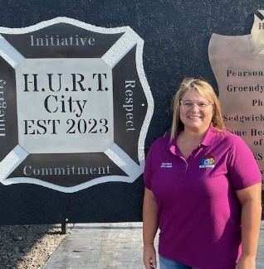
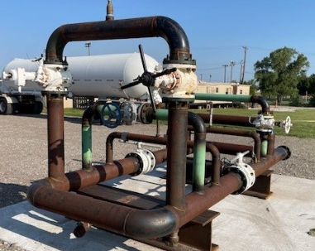
Our Local Emergency Planning Committee chairperson, Ann Houk, was instrumental in the addition of three new training stations at the Regional Fire Training Center. HURT City (Heavy Urban Rescue Training) will give firefighters from all departments the chance to train on some of the most hazardous scenarios they can encounter, but under controlled conditions.

There is a pipeline junction provided by Phillips 66; a semi tanker from Groendyke Transport; and a BNSF rail tank car.

But before any of that could be installed, a section of the training grounds had to be landscaped and concrete pads and train rails installed. All that work was done by Pearson Construction.
This could have been an incredibly expensive project, but Ann worked with all the companies mentioned above to donate their portion of the project free of charge!

Most of Ann’s coordination was time-consuming, but somewhat routine; one piece, however, most certainly was not. BNSF could get the railcar as close as a spur line across the street from the RTC at Spirit, but there needed to be some way to move it the last several hundred yards to its new home in HURT City. There were only 2 companies capable of making the move, and with a price tag well over $20,000, they were not going to be donating their services. But Ann found a grant that could be used to cover the cost, and in late summer 2023 HURT City was dedicated with full media fanfare.
https://www.kwch.com/2023/08/19/wichita-fire-dept-expands-opportunities-with-new-training-site/
https://www.ksn.com/news/local/new-facility-will-train-fire-crews-for-major-rescue-operations/

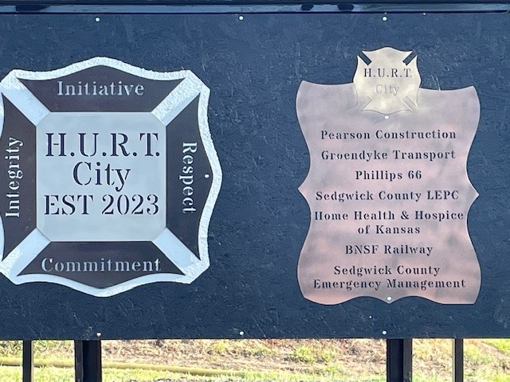
Wichita Fire Training Chief Ryan Gadbury praised Ann and the Sedgwick County LEPC, saying this facility “is a platform that will serve hundreds of first responders from agencies all over the U.S. for decades to come. The ability to conduct on-site training over highway transportation, rail car emergencies, pipeline & manufacturing incidents, confined space response, or to mix multiple components together to simulate a scalable disaster scene, is a convenient and highly functional tool for responder education.”

Community Emergency Response Team (CERT) Basic Training Weekend
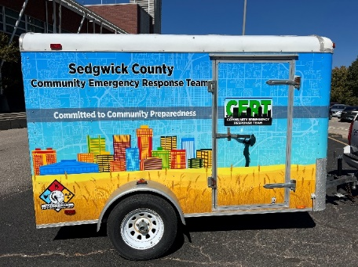
We relaunched our Community Emergency Response Team (CERT) Basic Training Program this year and it’s been a true collaboration. The CERT program, provided by FEMA, offers a consistent, nationwide approach to volunteer training and organization that professional responders can rely on during disaster situations, allowing them to focus on more complex tasks. In a disaster situation, all of our resources are typically committed immediately. The need for help and emergency services becomes far greater than we’re able to initially provide. CERT gives knowledge and skills to community members so they may be better prepared for the effects of disaster and also safely respond to the needs of their neighbors. During the April 29th Tornado, there were few Police, Fire, or EMS rescues that occurred. It was neighbors who largely assisted the trapped or injured. This exact scenario is the gap that CERT Basic Training fills.
CERT Basic Training is a collaborative program led by Emergency Management which includes participation by local police departments, fire departments, EMS, Active Duty Military, and more. This program builds resiliency within Sedgwick County and supplements our emergency response efforts in the early wake of a disaster.

Planning
Region G Hazard Mitigation Plan
The Region G Hazard Mitigation Plan is a comprehensive plan for 11 counties located in the South Central part of Kansas. This plan is reviewed throughout the region every five years and 2024 is the year for the next review. Jonathan has already begun reaching out to key stakeholders to begin the review process. This plan identified hazards common to the area and provide sustained actions to eliminate or reduce risk to people and property from the effects of natural and man-made hazards. This plan identified local hazards, vulnerabilities, and mitigation strategies. This plan serves to direct resources towards creating policies, plans, and actions that provide long-term risk reduction benefits to communities.

Continuity Plans
Continuity plans identify an organization’s essential functions and develop actions to restore those functions as quickly as possible during disruption. Jonathan will be working with jurisdictions, government agencies, and businesses to review plans in place and to help develop continuity plans for those without a plan.

Preparedness

Emergency Management Launches Civic Ready Emergency Alerts!
In January of 2023, Emergency Management partnered with all of the cities in Sedgwick County as well as local emergency response organization to launch subscription-based Emergency Alerts through Civic Ready. Sedgwick County residents are able to select to receive public safety alerts from 911, Emergency Management, their local police or fire department in the event an emergency occurs in their neighborhood. Alerts can be sent to warn people of danger and advise them to evacuate, shelter in place, be on the lookout, or avoid an area. Additionally, Sedgwick County Health Department can send public health alerts and city governments can send community bulletins. Civic Ready adds another tier to our layered approach to public warning. When time is on the line and lives are at stake, it’s difficult reaching everyone where ever they are, inside, outside, at home, at work, shopping, at school and the like. Civic Ready joins other emergency alert methods in our arsenal such as Wireless Emergency Alerts(WEA), Emergency Alert System(EAS), NOAA weather radios, and outdoor warning sirens. Emergency Management advertised for the public to sign-up for this free service through a commission meeting, local media, social media, and video ads played on the jumbo-tron at Wind Surge games.
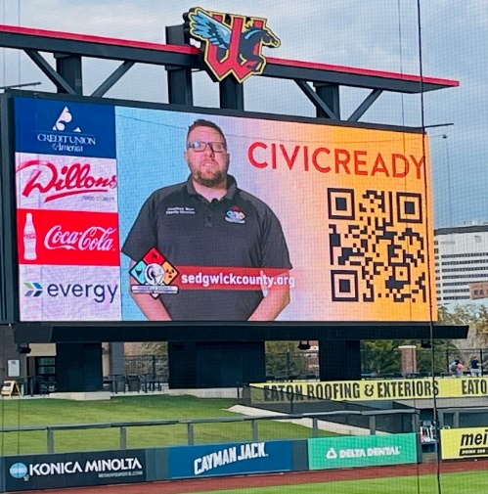
- Commission Meeting: https://www.youtube.com/live/Mw-SXN0YbNc?si=74I1JIvlm1dTT2Mq&t=262
- Wind Surge: https://www.youtube.com/watch?v=HtJEtj8TSNo
- Halloween: https://www.youtube.com/watch?v=npC0AC9K9V0
- https://www.kwch.com/2023/09/16/sedgwick-countys-civic-ready-alerts-keep-citizens-informed/
- https://www.ksn.com/news/local/how-to-sign-up-for-civic-alerts-in-sedgwick-county/
- https://www.kake.com/story/48177793/sedgwick-county-unveils-free-public-alert-system
- https://www.derbyinformer.com/news/derby_news/county-unveils-new-public-alert-system/article_96d4cd06-9c08-11ed-84cc-536f53ef74e6.html

Outdoor Warning Capital Improvement Project 2023-2028
As you may know, a decade ago, the County inherited all of the aged outdoor warning sirens from every city and jurisdiction within the county, as well as parts of Mulvane in Sumner County in an effort to standardize our alerting method and provide selective warning along-side the National Weather Service. Prior to 2012, each city ensured siren coverage within their own boundaries. The sirens, as they exist today, were never designed to work as one comprehensive system. The system as it exists today is more haphazardly piecemealed together than it is a cohesive unit. We have equipment as with install dates of 1953 up to 2023. The 2012 effort to consolidate the various siren makes/models under one software was good in theory, but has not served us in a manner we can accept nor afford.

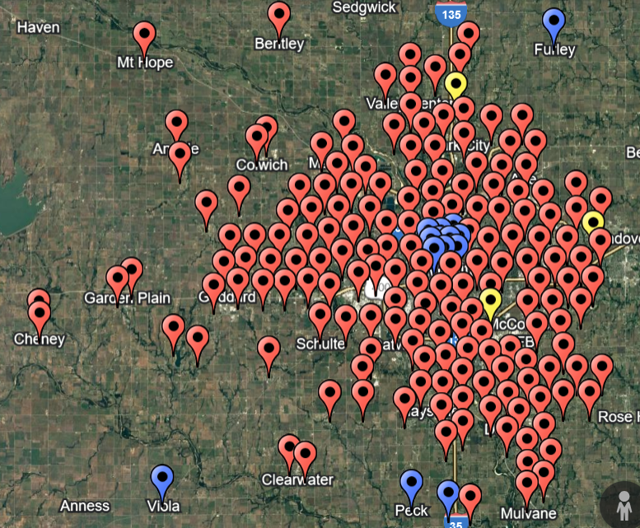
As part of a 6-year, $3.8 million capital improvement project (CIP) approved by the County Commission, Emergency Management will be replacing or refurbishing 100% of the county’s outdoor warning system. This large project will be tackled year-to-year, by zone, and community by community. In November of 2023, sirens in the cities of Clearwater, Garden Plain, Viola, Colwich, Furley and areas in the western side of the county all received new sirens. In 2024, the cities of Mulvane, Derby, and areas of the County east of McConnell AFB will receive new outdoor warning sirens. The project will not only replace existing sirens but also expand coverage to under-served areas of the county. This project will also include removal of the old existing equipment. Installations are not yet scheduled for 2024, however PO’s will go out in Jan/Feb of the new year. We typically This green project comes with brand new solar-powered Federal Signal 508 mechanical rotating sirens and the refurbishment of existing Federal Signal 2001 mechanical rotating models. These two model sirens are considered the industry standard in terms of outdoor warning equipment.

This new CIP gave us the opportunity to build a data-driven solution for one county-wide master-planned siren system to cover 98% of populated areas. The above map and associated pins is the result of a SoundPlan study we conducted to determine the best possible placement for outdoor warning sirens. SoundPlan is a powerful acoustic modeling software that allows us to visualize the effects of sound traveling through air and space. There is no industry standard by which to follow for the design, installation, or implementation of an outdoor warning system, however, FEMA references an outdoor warning study that it takes 70-decibels(dbs) to draw someone’s attention away from whatever they’re doing. So, our minimum target within the SoundPlan is 70dbs. FEMA also recommends the sound from the siren reside in the 500Mhz range as it tends to carry farther than a higher pitch. With the inputs set for 500MHz to achieve 70dbs, SoundPlan provided an output of the best possible locations based on maximizing populated areas and considering sound barriers such as topography, highway noise, tree & building height, industrial noise and more.

This is a large and widely impactful project, that when finished, will be heard by over ½ million people.

Exercises
U.S. ArmyNorth Full-Scale Exercise
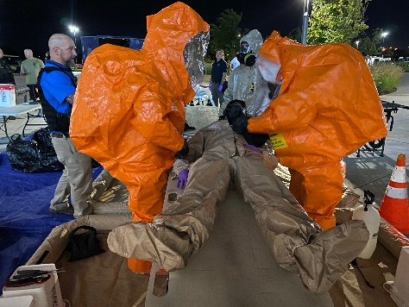
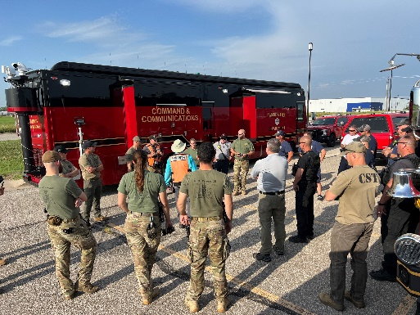
On July 25 and 27 Sedgwick County jurisdictional responders participated in two full-scale exercises with the US Army North-Bravo Team. These exercises focused reinforcing response tactics and relationships between Sedgwick County first responders and the 73rd Civil Support Team. Sedgwick County Emergency Management worked closely with ARNORTH in the design and control of the two exercises. The first exercise was an overnight exercise hosted at the Sedgwick County Zoo. The scenario was simulating a suspicious device thought to contain a hazardous material that needed additional assets to identify and mitigate the effects of the material. The second exercise was held at Hartman Arena and involved a simulated suspicious package thought to be explosive. Both exercises identified several area of strengths as well as some areas for improvement between all partner agencies.

Eisenhower National Airport Full-Scale Exercise
Every three years, ICT airport is required by the FAA to host a full-scale exercise simulating a passenger plane crash. This exercise gives the airport and all of our regional response partners with police, fire, EMS, hospitals, non-profits and opportunity to dry run an incident of this magnitude. Nearly a hundred high school students participated as simulated survivors of crash. This was the first year the airport invited emergency management to conduct a properly document HSEEP exercise with objectives and evaluators.

Wichita State University Athletics Table-top Exercise at Koch Arena
WSU Athletics hosts over a hundred events at Koch Arena annually. These events draw thousands of people to their campus. In December 2022, Emergency Management participated in a table-top exercise with Campus Police and WSU Athletics department to walk through various scenarios involving sheltering-in-place or evacuations. The table-top was a success and led to further plan revisions.

Logistics
Life after a Global Pandemic
The distribution of Personal Protective Equipment (PPE) in Sedgwick County has undergone significant shift since the onset of the COVID-19 pandemic. As we move beyond the global threat of the crisis, several notable changes have been added to how we conduct our daily duties. For instance, the County is more mindful and now routinely uses PPE such as gloves and masks as part of normal operating tasks. When employees feel sick or have been in close contact with someone ill, it has been a common place to mask up or take a sick day off and not try to “tough it out” as we did before.
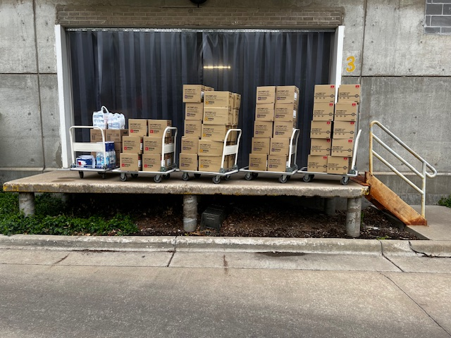
When it comes to our distribution process, Emergency Management continues to operate on a first-come, first-serve basis, emphasizing accessibility of products while supplies last. Our County departments are still encouraged to submit their needs using our online portal and view the items on our Fishbowl ecommerce site hosted by LilyPad. Link here: SgCo PPE Portal. If there are items you used to get and are not available not you can submit your request any time to logistics@sedgwick.gov
As vaccination rates increase and COVID-19 cases decline, the urgency for PPE has diminished as expected. Requests for PPE have gradually slowed down, reflecting the changing dynamics of the pandemic and the community’s adaptation to new norms. The good news is that our workplaces continue to prioritize PPE. The focus in Sedgwick County Government has shifted toward maintaining a steady supply for Adult Detention facilities, Juvenile Detention Facility, District Court facilities, and Risk Management department.
In summary, the distribution of PPE in Sedgwick County has adapted to the changing pandemic landscape. While individual requests have slowed down, the commitment to providing essential protection remains steadfast. Especially for those employees on the frontlines in close vicinity with mass gathering of detainees living in confined spaces and the constant rotations of the general public who visit the District Court system.
End of year Numbers 2023
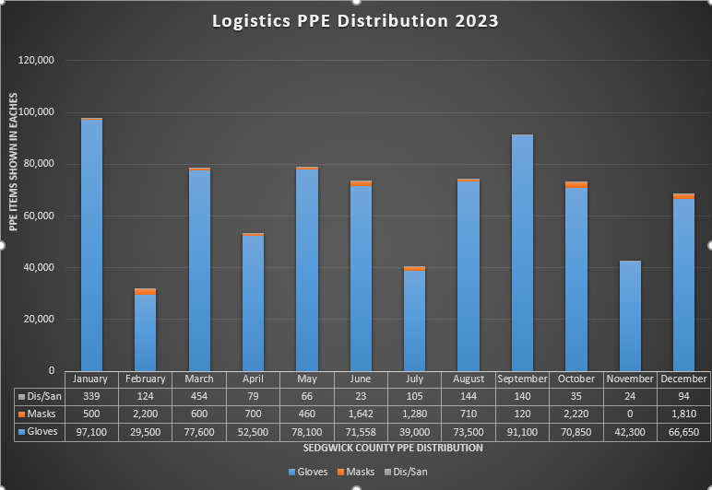
The grand total of PPE items distributed for 2023 was 808,625. That is 206,703 items less than the year before. Broken down by item that’s, 1,580 cases of gloves, 13,340 individual masks, and 1,104 disinfectant/sanitizer products of varies kinds. For 2023, the total number of requests were 126 valued at $272,971.58 of ARPA spending. Kenji drove 87.3 miles to fulfill the requested needs of our co-workers/customers. Our customers included 16 different County Departments, 1 City of Wichita agency. There were no COVID-19 outbreak emergency requests for PPE items made in 2023. With all of this data collected it gives us a clearer picture of what our true needs are to protect our employees/customers from future outbreaks.
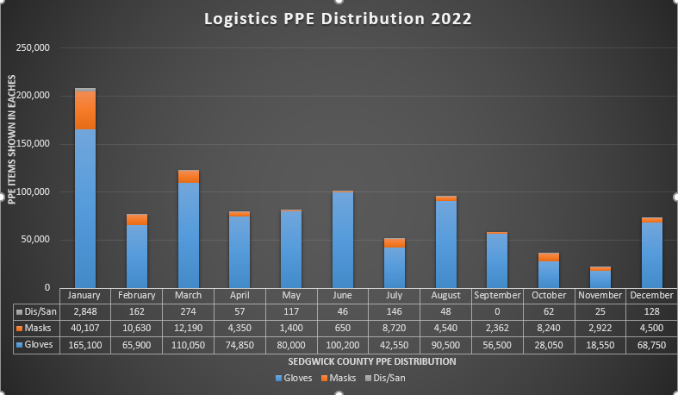
Comparing this chart from our previous year annual report, you will see we the massive decrease compare it to 2022. The number one most requested PPE items from County Departments were medical grade nitrile gloves as indicated in blue on the charts. Emergency Management’s number two most requested item were masks of all types. Disinfectants and hand sanitizer are still available for distribution but nowadays readily available everywhere. This year to maintain our operation we spent $120,349.10 of APRA funding to replace items that went out to our internal County employees/customers. The current EM expenditures budget does not cover the cost of sustaining the current 90-day supply for local government agencies and back up supplies for first responders without external assistants. So, in preparation for the 2025 budget year we requested that $125,000.00 to be added to our general fund. This proposal will help us fulfil our continuity of operation planning (COOP) initiatives by ensuring adequate PPE supplies will be in place for future Public Health disease outbreaks, pandemics and supply chain shortages.

Operations/Response
Fortunately, the Emergency Operations Center never went to level 1 (full) or level 2 (partial) activation in 2023. There were several level 3 “monitoring” activations for severe weather and to monitor a fuel spill from an overturned semi. Several partner agencies (Wichita PD, Wichita Fire, Wichita Public Works attended elog/EOC operations training in 2023.

In the media
https://www.ksn.com/news/local/sedgwick-county-emergency-management-k9-and-handler-find-missing-child/
https://www.kake.com/story/46609063/sedgwick-county-emergency-management-warns-citizens-of-ongoing-flooding-risk
https://www.ksn.com/weather/weather-stories/watch-live-city-of-wichita-on-dangerous-cold-and-snow-in-forecast/
https://www.kake.com/story/46563383/sedgwick-county-emergency-management-on-high-alert-for-another-night-of-rain-and-possible-flooding
https://www.kwch.com/2022/03/24/sedgwick-county-k9-team-aids-search-missing-person/
https://www.ksn.com/weather/weather-stories/storm-track-3-historical-tornado-siren-significance-marking-70-years/
https://apnews.com/article/tornadoes-storms-weather-kansas-wichita-cd1d6dc8a2143f43a6bdda785a8484e1
https://www.kfdi.com/2022/12/21/wind-chill-warning-to-be-in-effect-city-prepares-for-winter-storm/
https://www.kake.com/story/46028780/tornado-vs-attack-whats-the-difference-between-a-tornado-warning-and-impending-attack-warning-in-kansas
https://wichitabeacon.org/stories/2022/05/31/public-service-award-sedgwick-county/
https://www.ksn.com/news/good-news/sedgwick-county-employee-gets-surprise-honor/
https://www.cbs19news.com/story/45010233/ever-wanted-to-join-investigators-in-active-missing-person-cases-sedgwick-county-has-a-volunteer-team
https://www.ksn.com/news/local/sedgwick-county-k-9-helps-brings-closure-to-fire-search/
https://www.youtube.com/watch?v=wH-VeFB7ZsI
https://www.youtube.com/watch?v=ZOlC_P-Azhw
https://www.youtube.com/watch?v=lOQqOGmFFXU
https://www.youtube.com/watch?v=pCAL6iqwR-U

